=====12/11/2022=====

Group ID: 07

Project name: Cadger

Prepared by: **Nguyễn Khải Phú**

Team members:

20127124 - **Đặng Bảo Châu** *Project manager*

20127062 - **Nguyễn Khải Phú** *Process engineer*

20127068 - **Hồ Minh Thanh Tài** *Business Analyst*

20127045 - **Võ Đình Khôi** *Test Manager*

20127406 - **Thái Cẩm Phong** *Software Engineer*

# **Summarize**

Everyone worked productively and met their deadlines. Mr. Phong has worked exceptionally hard this sprint. Meeting times are not announced early enough, which has led to some members being late. In the future, meeting times will be posted 1 day in advance.

1. **Screenshots of all tasks**

* Bảo Châu

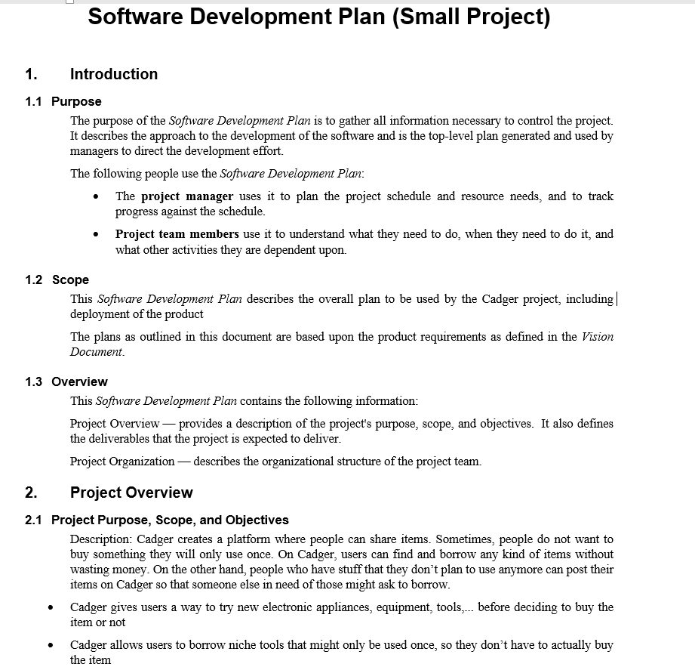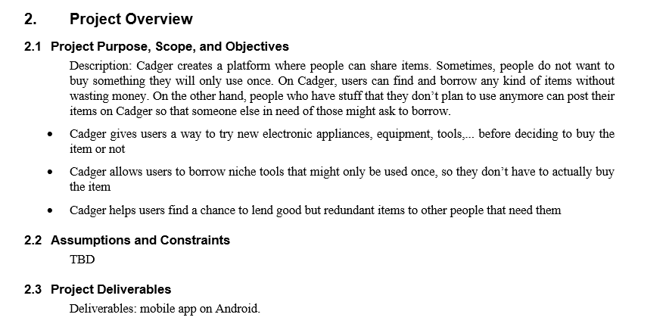

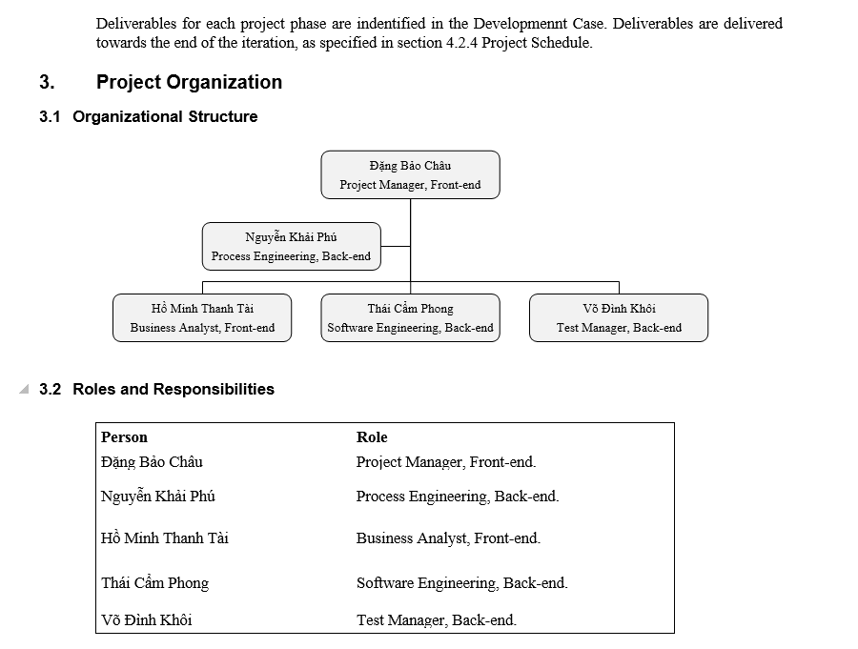

* Khải Phú

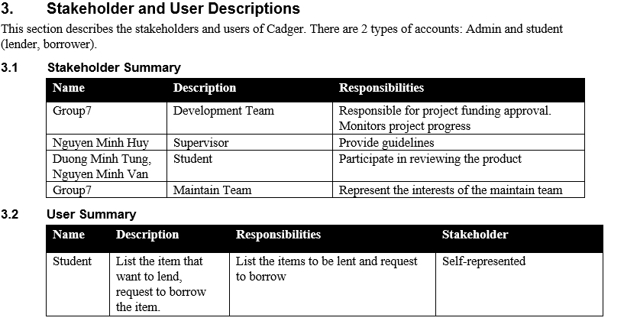

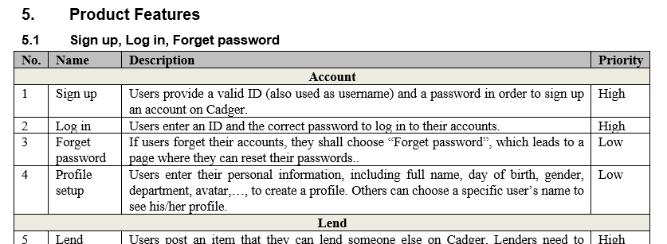

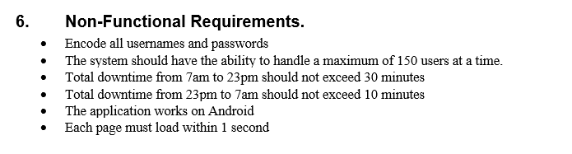

* Cẩm Phong

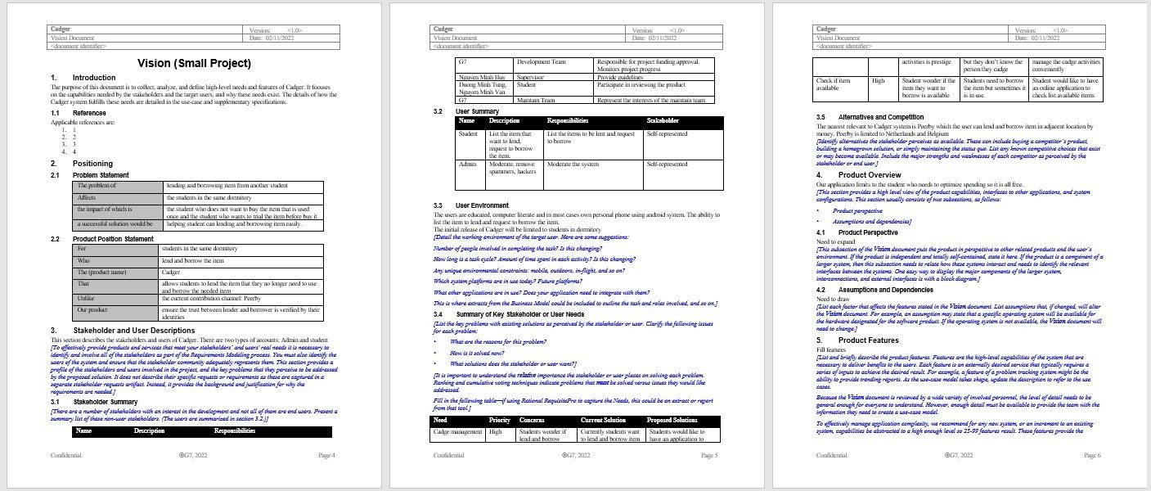

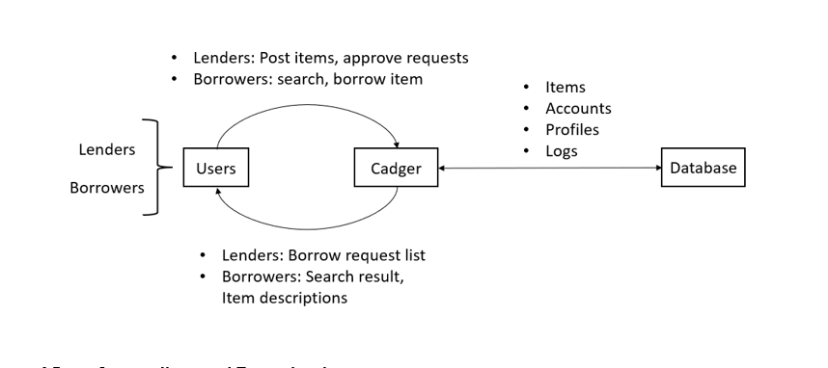

* Đình Khôi

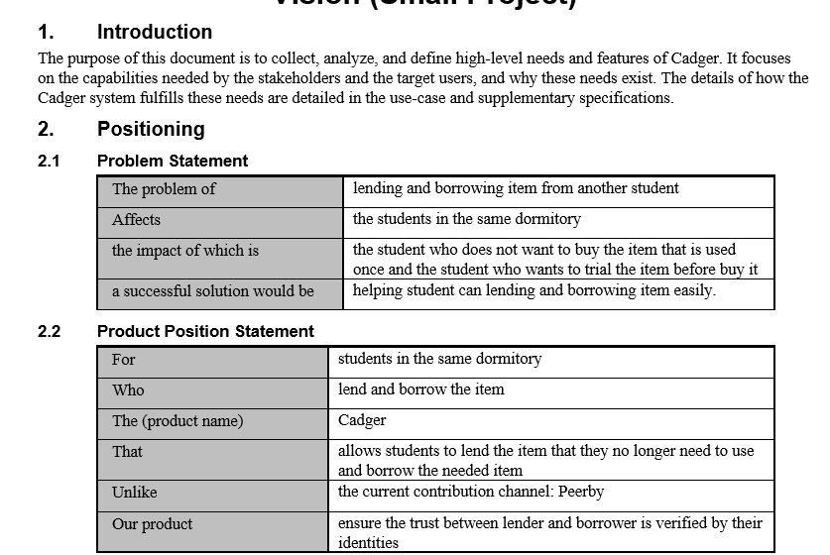

* Thanh Tài

